***ANIMAL HUSBANDRY***

MINI-PROJECT - II REPORT



Submitted by:

Hitesh Sharma Shubhang Verma

(181500272) (181500703)

Jai Sharma Pranshul Agrawal

(181500289) (181500484)

Submitted to: **Mr. Vinay Agrawal**

(Assistant Professor)

Department of computer Engineering & Applications

### Institute of Engineering & Technology



**Declaration**

We hereby declare that the work which is being presented in the B. Tech. Project **“Animal Husbandry”**, in partial fulfillment of the requirements for the award of the ***Bachelor of Technology*** in Computer Science and Engineering and submitted to the Department of Computer Engineering and Applications of GLA University, Mathura, is an authentic record of my/our own work carried under the supervision of **Mr. Vinay Agrawal**, Assistant Professor.

The contents of this project report, in full or in parts, have not been submitted to any other Institute or University for the award of any degree.

**1**. Hitesh Sharma (181500272) **2.** Jai Sharma (181500289)

**3.** Pranshul Agrawal (181500484) **4.** Shubhang Verma (181500703)

**Certificate**

This is to certify that the above statements made by the candidate are correct to the best of my/our knowledge and belief.

#### Supervisor

Mr. Vinay Agrawal Assistant Professor

Date: 23 April, 2021

# Acknowledgement

It gives us a great sense of pleasure to present the report of the B.Tech project undertaken during B. Tech third year. This project in itself is an acknowledgement to the inspiration, drive and technical assistance contributed to it by many individuals. This project would never have seen the light of the day without the help and guidance that we have received. We heartily thank to Dr. (Prof.) Anand Singh Jalal, Head of Dept., Dept of CEA for providing us with an encouraging platform to develop this project, which thus helped us in shaping our abilities towards a constructive goal.

We owe special debt of gratitude to Mr. Vinay Agrawal, Assistant Prof., Dept. of CEA for his constant support and guidance throughout the course of our work. His sincerity, thoroughness and perseverance have been a constant source of inspiration for us. He has showered us with all his extensively experienced ideas and insightful comments at virtually all stages of the project and also taught us about the latest industry oriented technologies.

We also do not like to miss the opportunity to acknowledge the contribution of all the instructors who are available on Youtube. Last but not the least, we acknowledge our friends for their contribution in the completion of our project.

With Sincere thanks,

1. Hitesh Sharma (181500272)

2. Jai Sharma (181500289)

3. Pranshul Agrawal (181500484) 3. Shubhang Verma(181500703)

# Abstract

Animal Husbandry is a simple yet very useful application developed using flutter where users will be able to get answers to their pet related health issues. The Main target of Pet care are the users who want to be sure about the information they get to decide their next set of actions.

In this application chatbots will be available for animals like dogs, cats and cows. Users will have to sign up to use the app, and they can use the chatbot dedicated to the animal they wish to know about. The app was developed using flutter therefore it can be used in both IOS and android devices. The chatbots were developed using dialog flow which provide us with many tools to analyze and make the chatbots more interactive in the future.

To reach or getting the exact root cause for such problems can get difficult and time-consuming plus whether the information gathered is true or not, it’s hard to tell. Keeping all this in mind we decided to build an app which will not only help you to get reliable information but will also help to take the next step of actions.

## Contents

Declaration i

Certificates ii

Acknowledgement iii

Abstract iv

Chapter 1 Introduction 6

* 1. General introduction to the topic 6
  2. Software and hardware requirements 6
  3. Objectives 7
  4. Implementation Details 8
  5. Roles 9
  6. Issues and challenges faced 10
  7. Software testing 11
     1. Blackbox testing
     2. Whitebox testing

Chapter 2 Software Design 12

* 1. Use Case diagram 12
  2. DFD level 0 13

level 1

* 1. E-R diagram 14

Chapter 3 User interface (screenshots) 15

* 1. Splash Screen 15
  2. Welcome Screen 17
  3. Registration Screen 19
  4. Login Screen 20
  5. HomeScreen 21
  6. DogBot screen 22
  7. CatBot Screen 23
  8. CowBot Screen 24

Chapter 4 Conclusion 25

Chapter 5 Bibliography 26

# Introduction

#### General Introduction to the topic

“Loving your pet like you do” is the motto keeping which in our mind we developed this project. The function of our app exactly resembles its name “Pet-Care”. This app gives you quick and reliable solutions to all your pet related queries ; having chatbots dedicated for domestic animals like dog, cat and cow. We selected almost all most common health issues which these animals suffer from and have tried to find as reliable answers as we could.

The concept of chatbots has not been new for our technologically advancing society. A chatbot is a computer program, when provided with inputs in Natural Language (English, French etc) responds with something meaningful in the same.

We’ve tried to develop this simple yet very useful app over this concept, this app will prove to be helpful to many new pet owners who have no one to guide them.

#### Hardware Requirements:

👉 System having at least 4 GB of RAM

#### Software Requirements:

👉 Flutter (1.20.1)

👉 Android Studio (3.6)

👉 OS : Linux or Windows

**1.3 Objective**

When we are new as a pet owner and sometimes even when we have some experience we use the internet to search out answers when we find our pets behaving unusually or sick, to which we find a good deal of health related articles with the same symptoms but different problems.

To reach or getting the exact root cause for such problems can get difficult and time-consuming plus whether the information gathered is true or not, it’s hard to tell. Keeping all this in mind we decided to build an app which will not only help you to get reliable information but will also help to take the next step of actions.

### Implementation Details

#### Part 1:

We discussed the UI of our project and how we will proceed to build it.

#### Part 2:

We worked on the splash screen and welcome screen of our app.

#### Part 3:

We added the functionality of logging in and signing up using Firebase. We also developed chatbots using dialogflow.

#### Part 4:

We added the home screen and embedded the chatbots into our application.

### 1.5 Roles

|  |  |  |
| --- | --- | --- |
| **Hitesh Sharma** | **Pranshul Agrawal** | **Shubhang and Jai** |
| Catbot | Cowbot | Dogbot |
| Login Screen | Splash Screen | Welcome Screen |
| Signup Screen | Styling | Home Screen |
| Firebase Authentication |  | Dogbot ChatScreen |
|  |  | Catbot ChatScreen |
|  |  | Cowbot ChatScreen |
| E-R Diagram | DFD | Use Case Diagram |

## Issues and Challenges Faced

In the Development of this project we faced some problems. The major problem was the lockdown due to COVID-19, it affected the overall communication in the team while discussing the project although we have done a lot of virtual meetings on ZOOM to overcome this problem.

It was our first project that’s why it took some time to plan everything, we had to choose the technologies that we were bit familiar with, and then we had to work on learning flutter for which we did a course from Udemy which gave us better understanding about moving forward with our idea. For building chatbots we explored platform like Azure, Amazon lex and Google dialogdlow which was hectic and time-consuming but in the end we chose to go with dialogflow as it was easy to understand and work with. It also provided us with the ability to embed chatbot in our application which we were unable to find in any other platform.

### Software Testing

* + 1. BlackBox testing:

|  |  |  |  |  |
| --- | --- | --- | --- | --- |
| Test Name | Test Date | Expected Result | Actual result | Status |
| Mismatch message | 20 April 2021 | A mismatch message would | A mismatched message | Successful |
|  |  | appear on entering the | appeared on entering the |  |
|  |  | wrong password or | wrong password or |  |
|  |  | email. | email. |  |
| Text overflow | 20 April 2021 | No text would | No text got | Successful |
|  |  | get overflow when the | overflow when the answer got |  |
|  |  | answer will get fetched from | fetched from dialoflow. |  |
|  |  | dialoflow and displayed. |  |  |

* + 1. WhiteBox Testing

|  |  |  |  |  |
| --- | --- | --- | --- | --- |
| Test Name | Test Date | Expected Result | Actual Result | Status |
| Login match | 20 April 2021 | Username and password should get matched. | Username and password got matched. | Successful |
| Buttons | 20 April 2021 | Chatbot of that particular animal should be opened whose button has been pressed. | Chatbot of that particular animal get opened whose button has been pressed. | Successful |

* 1. **Software Design**
  2. Use Case Diagram

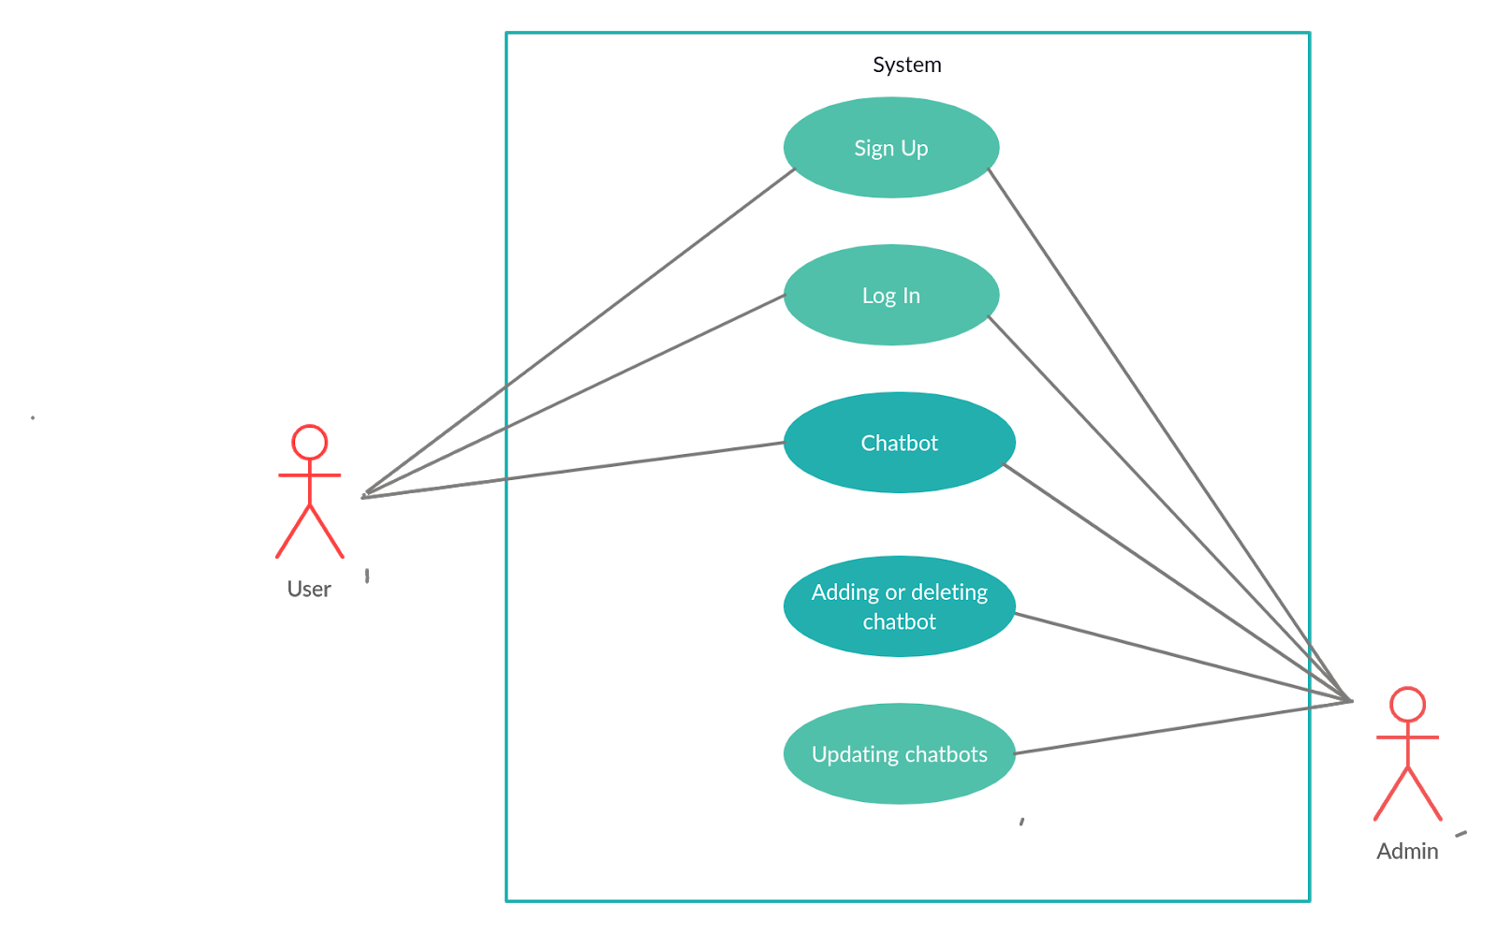

Figure 2.1 Use Case Diagram

* 1. DFD

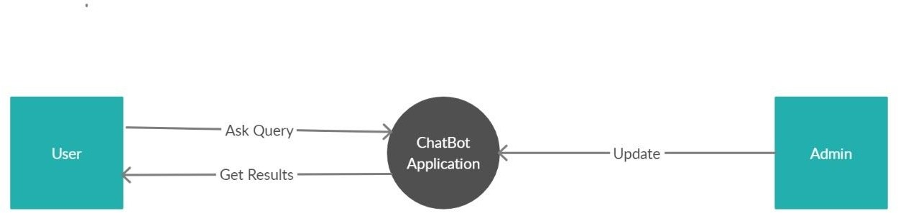

Figure 2.2 level-0 DFD

level-0

Level-1

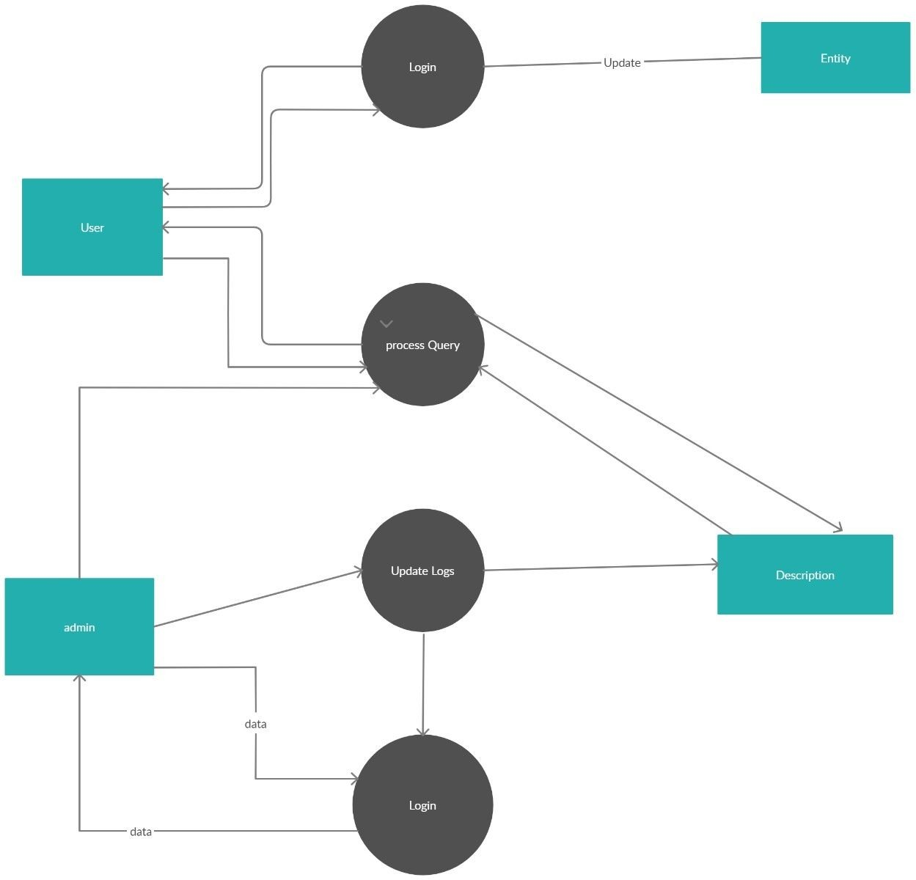

Figure 2.3 level-1 DFD

* 1. E-R Diagram

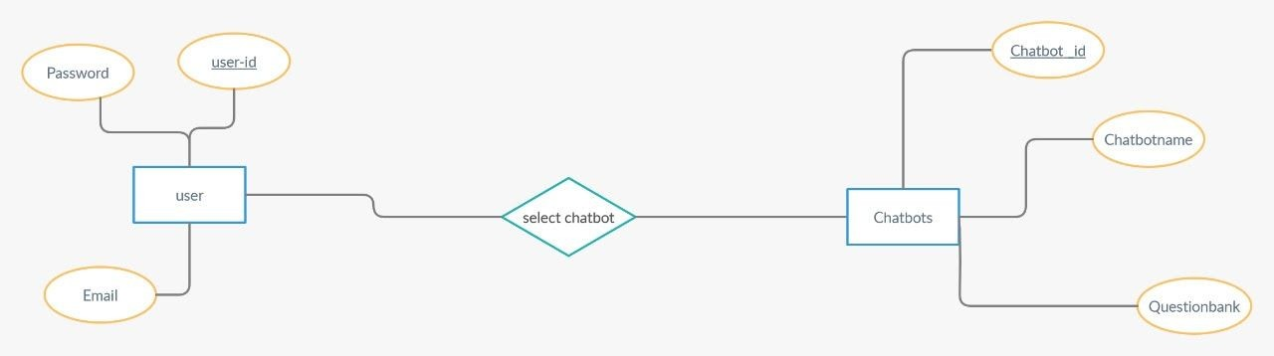

Figure 2.4 E-R Diagram

### User Interface (Screenshots)

* 1. Splash Screen

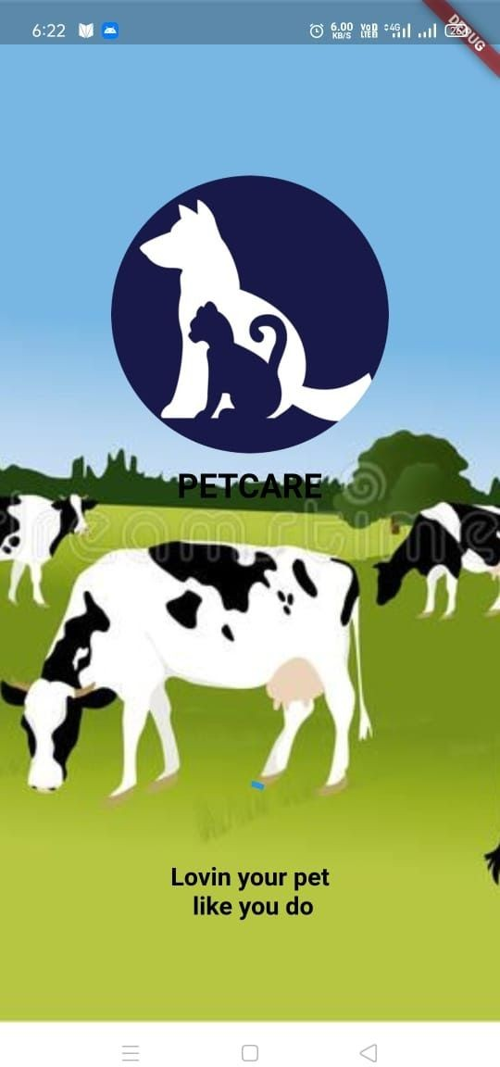

Figure 3.1 Splash Screen

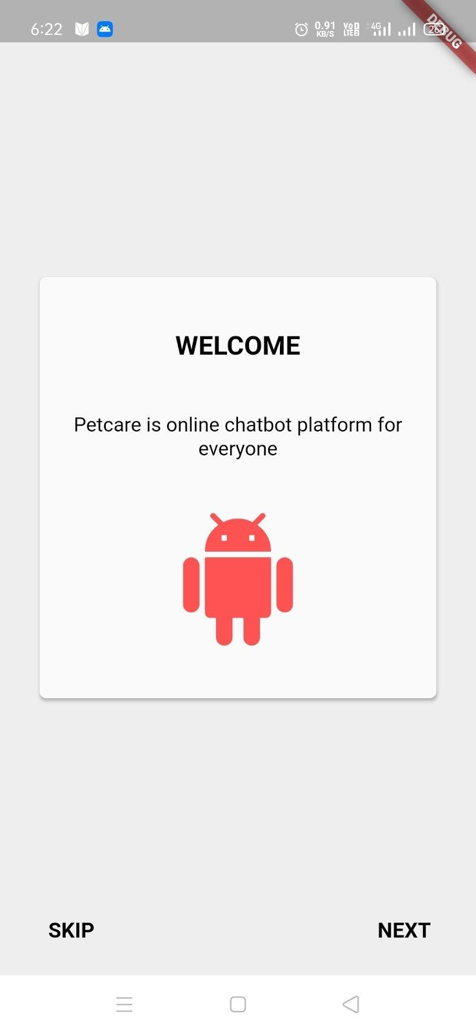

Figure 3.2 Splash Screen 2

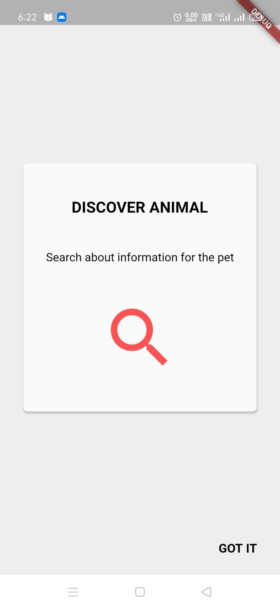

Figure 3.3 Splash Screen 3

* 1. Welcome Screen

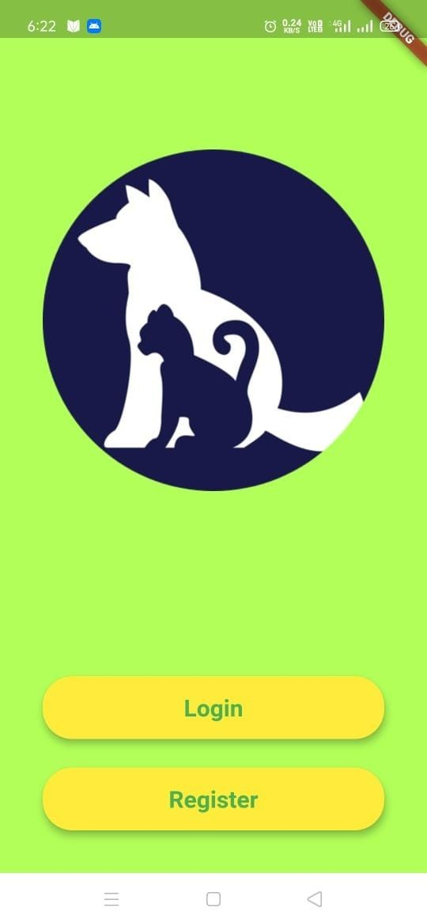

Figure 3.4 Welcome Screen

* 1. Registration Screen

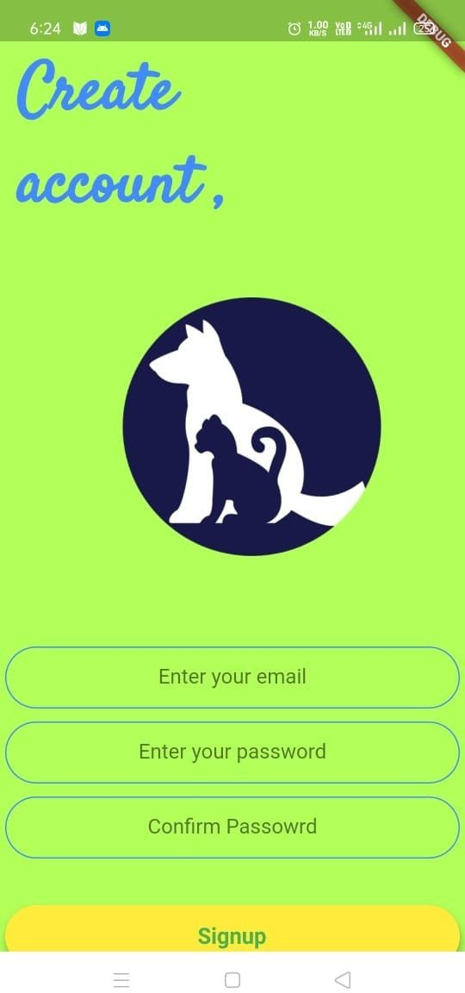

Figure 3.5 Registration Screen

* 1. Login Screen

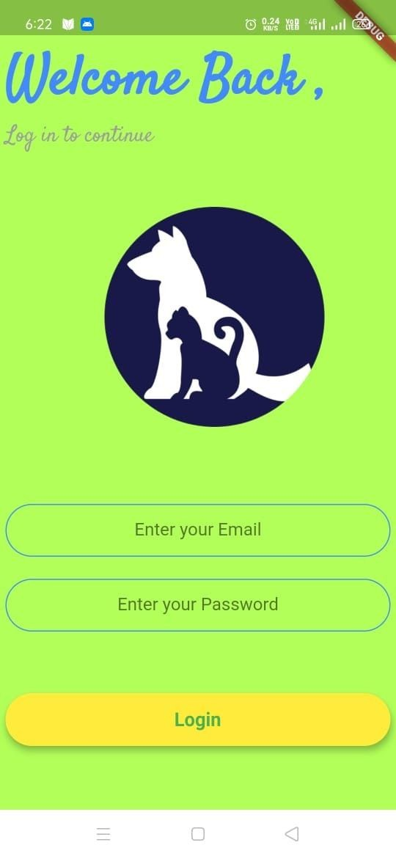

Figure 3.6 Login Screen

* 1. HomeScreen

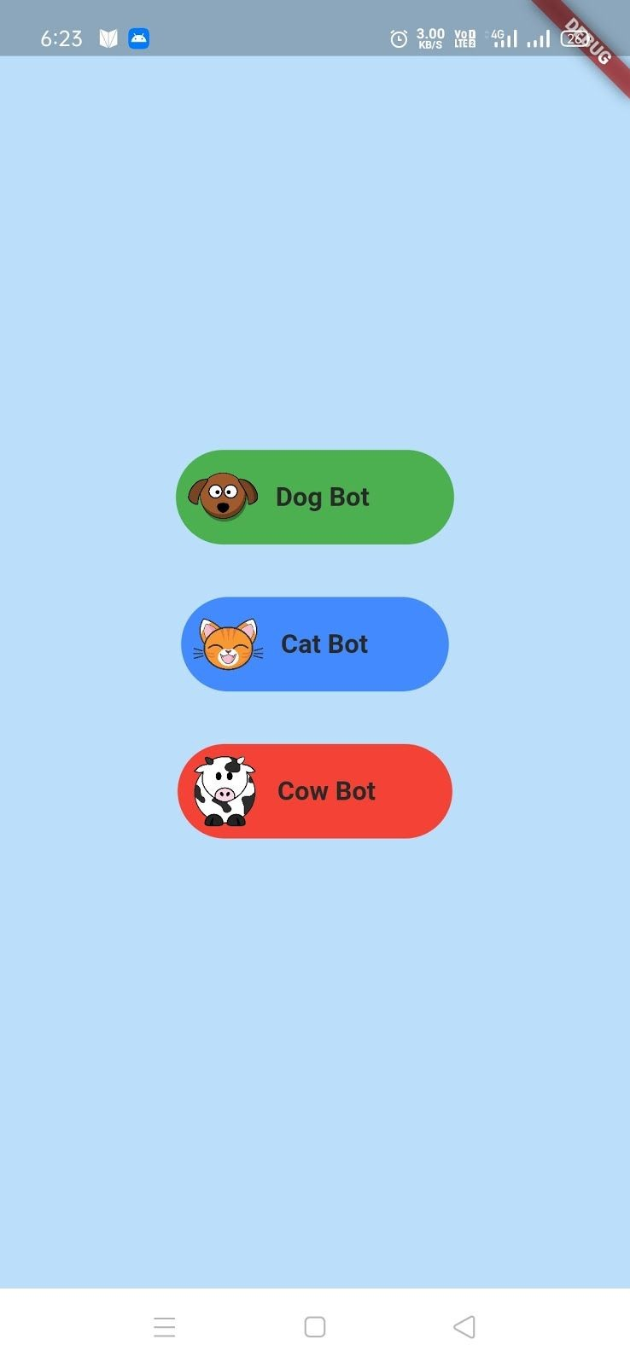

Figure 3.7 HomeScreen

* 1. DogBot

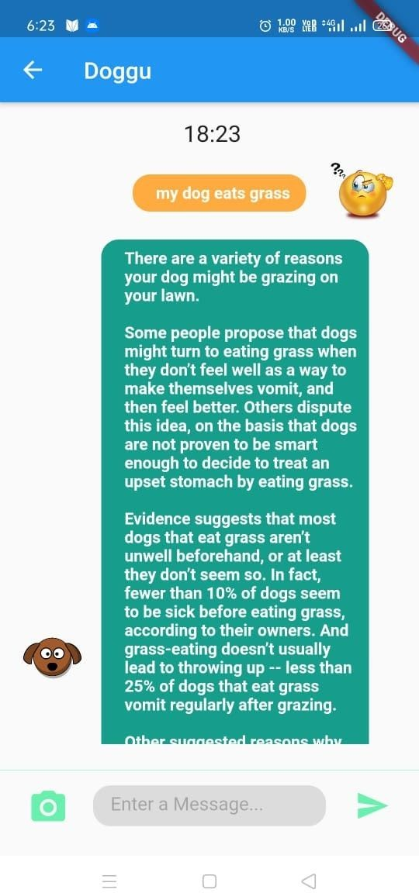

Figure 3.8 DogBot

* 1. CatBot

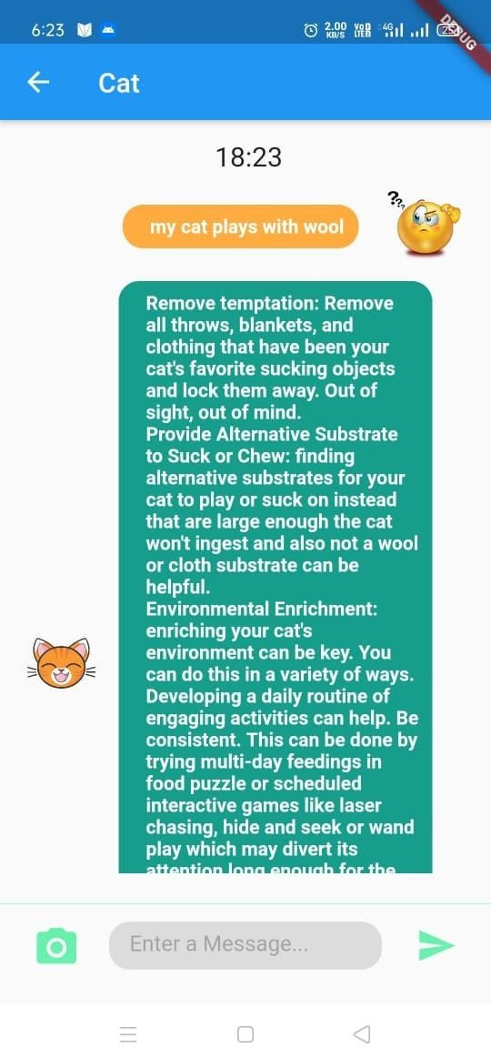

Figure 3.9 CatBot

* 1. CowBot

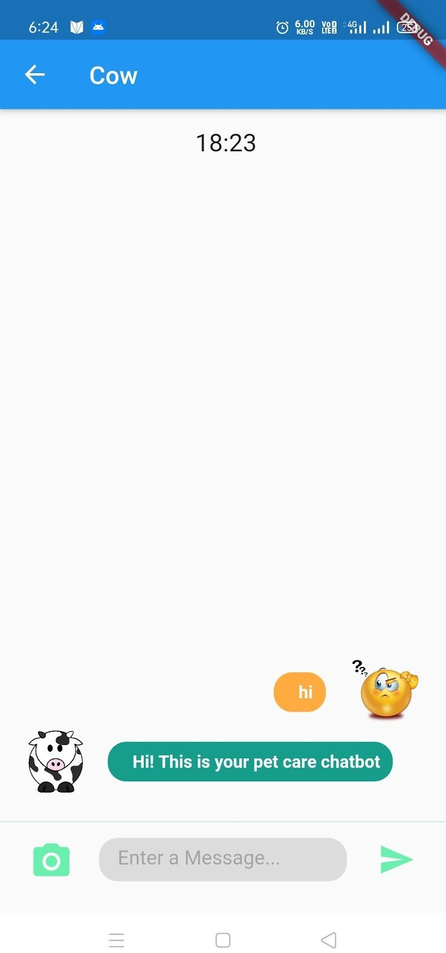

Figure 3.10 CowBot

## Conclusion

Animal Husbandry is an application that cares, it gives quick and reliable answers to all your pet health related queries. All you have to do is open the chatbot of animal you want to ask about, then just simply type and send your question, you will get your answer within a few seconds. We developed chatbots using dialogflow. We chose dialoglow because it was easy to work with, it supports 20 plus languages, it's very easy to embed chatbots into your app in comparison to other applications and it got tools to even analyze the performance of the chatbot.

Working on a project is never too easy, it teaches you lots of things though. When we think of some idea to work on we think about including many features to make the app as appealing and as good as possible but in the end there are always few things to get left because of one reason or another.

When we decided to work on this project we thought to make our chatbots very interactive by adding features rich buttons and provide features like dark theme in our app but due to lack of time and resources available on the internet about dialogflow we couldn’t include it in our application, but we’ve tried to provide as reliable answers as we could have for all common health issues that a pet could suffer from. This app helps the owners to find the answers for their pets in the quickest way. The technologies that we were a bit familiar with, and then we had to work on learning flutter for which we did a course from Udemy which gave us better understanding about moving forward with our idea.

## Bibliography

👉 h [ttps://www.appbrewery.co/courses/enrolled/851555](https://www.appbrewery.co/courses/enrolled/851555)

👉 YouTube.com 22-nov-2020

👉 h [ttps://flutter.dev/docs](https://flutter.dev/docs) 23-nov-2020